Military Cognitive Performance (MCP) Blueprint

The MCP Technician Certificate of Completion is intended for licensed or non-licensed active duty or military contractor support staff who want to demonstrate that they have followed a standardized training program to learn how to use the EEG and HRV biofeedback modalities to provide optimal performance training using these modalities.

***A BCIA Certificate of Completion is not a designation and as such, certificate holders will not be listed on the website. Only those who have completed the full certification process are listed.***

Application:
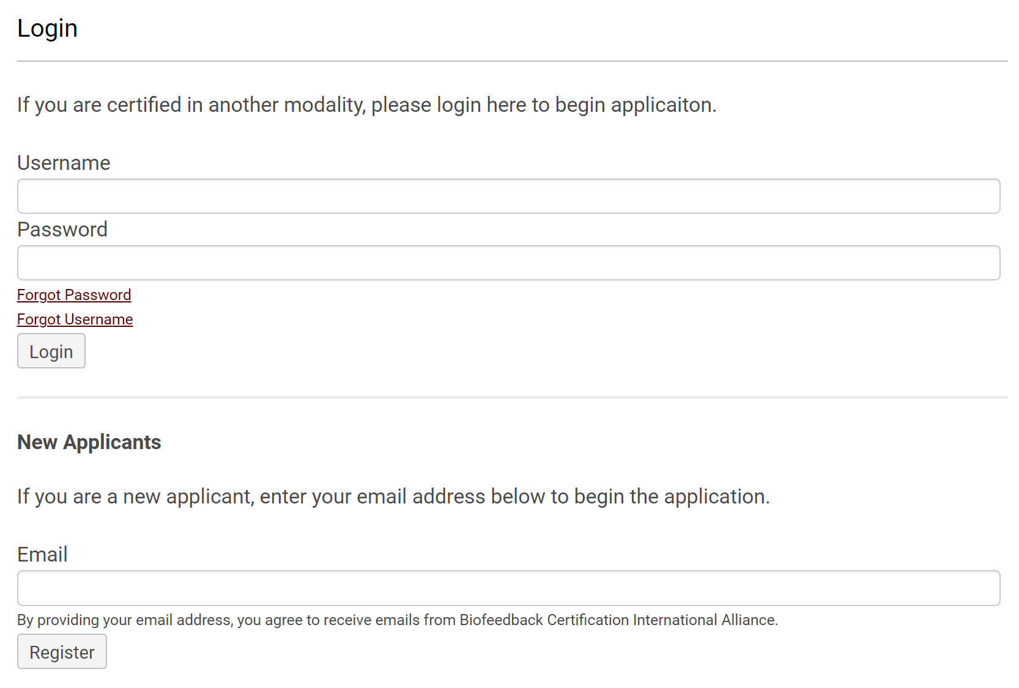

MCP Technician Certificate of Completion

Where do I start?
All applicants must:

1. Agree to abide by BCIA’s Professional Standards and Ethical Principles (PSEP),
2. Complete the BCIA-approved MCP Biofeedback Didactic Program
3. Pass a nationally standardized online exam based on the MCP 13-hour Blueprint of Knowledge and this Core Reading List. As of June 2018, the exam must be proctored, and there is a required pass score derived from the review of accumulated psychometric information.

Didactic Education: The MCP 13-hour Blueprint content is divided into 10 rubrics as follows:

- Orientation to Neurofeedback 1 hour
- Basic Neurophysiology & Neuroanatomy 1 hour
- EEG/QEEG/Neurofeedback Instrumentation 2 hours
IV. EEG/QEEG Assessment & Re-assessment 2 hours
- Neurofeedback Optimal Performance Protocols 2 hours
- HRV Anatomy and Physiology 1 hour
- HRV Instrumentation 1 hour
- HRV Meaning and Measurements 1 hour
- HRV Biofeedback Strategies 1 hour
- HRV Applications for Optimal Performance 1 hour

BCIA-Accredited Didactic Training Providers
Complete BCIA MCP Blueprint of Knowledge coverage may be documented by courses taken at annual conferences, when offered, or from the following BCIA Accredited MCP Training Programs. Each program is responsible for the content, pricing, schedule, and all other information for their course. Please contact the individual program, not BCIA, should you need further information.
Exam
**YOU MUST HAVE A VALID APPLICATION ON FILE BEFORE REGISTERING FOR THE EXAM!**
The exam may be taken at any time after approval of your application and payment of all fees; however, we recommend it is the last requirement in the process.
Us the Exam Registration Form to register.

BCIA has partnered with an online proctoring service that uses cameras and artificial intelligence to monitor your exam progress, even as you test using your own computer.
Once your fees are paid to BCIA and the exam date selected, we will provide you with contact information for this proctoring service. You will need to register with them and pay their $20 proctoring fee. You must register with the online proctor at least 3 days prior to the exam date to insure they have enough proctors.

All fees are non-refundable and must be in US funds and paid by check, money order, or credit card.

The examination is offered in English only and is based on the Blueprint of Knowledge Statements. The exam consists of 50 multiple-choice items, and the number of exam items from a blueprint area corresponds to the number of hours in that rubric; the smaller the rubric, the fewer questions will be in the exam from that content area. There is a 2-hour time limit for the exam.

- A MCP Core Reading List is provided to aid in preparation for the exam and to reinforce the learning of the science, history, and theory of HRV biofeedback.
- Should you need additional time or special accommodation due to language or other circumstances, please contact the office at info@bcia.org.
- Upon confirmation of observed cheating behavior, the candidate will be disqualified. The disqualified candidate will be notified, and the respective score(s) will be disregarded. Readmission for examination will be considered after two years when the candidate will have to reapply, pay all fees, and acceptance will be contingent upon review of credentials and requirements using criteria for admission applicable at the time of review.

Filing an application
You may file your application at any time you wish during the process. For the application to be valid, you must include your filing fee.

Fees
All applications must include a filing fee:
- $25 for all students enrolled in a health care degree program at a regionally accredited academic institution according to BCIA certification standards.
- $25 for all current BCIA certificants – BCB, BCN, BCB-PMD
- $50 for all other applicants
All fees are non-refundable and must be paid in US funds by check or online.

Requirements:
Candidates must demonstrate the completion of these four (4) requirements.

- Written approval of technician applicant by his or her military command authority where optimal performance using EEG and HRV biofeedback and EEG/QEEG is performed at the time of didactic education enrollment.
2. Didactic Education Satisfactory Completion
- A 12-hour didactic education program specifically covering all topics as listed in the MCP Biofeedback Blueprint of Knowledge is required and must be taken from a BCIA Accredited MCP Training Program.
3. Filing an Application
Fees include:
- $100 filing fee, which must be paid at the time the application is submitted.
- All fees are non-refundable, non-transferable, and must be in US funds and paid by check, money order, or credit card.
4. Certification Exam
**YOU MUST HAVE A VALID APPLICATION ON FILE BEFORE REGISTERING FOR THE EXAM!**
The certification exam may only be taken using our online proctoring service, which allows you to test on your own computer with no travel required. This service employs cameras and artificial intelligence to monitor exam security.

- Language: The examination is offered in English only and is based on the Blueprint of MCP Knowledge Statements
- Exam Construction: The exam consists of approximately 50 multiple-choice items with only one correct answer. No penalty for guessing. The number of exam items from a blueprint area corresponds to the number of hours in that rubric; the smaller the rubric, the fewer questions will be in the exam from that content area.
- How Much time will It take? There is a 2-hour time limit for the exam.
- How to Study: Please use the MCP Core Reading List to aid in preparation for the exam and reinforce the learning of the science, history, and theory of biofeedback.
- What if I need to reschedule? You are required to contact both the proctoring service and BCIA to let us know of your change of plans. Once your situation is resolved, you must reconnect with the proctoring service to find a new date and send that information to BCIA to ensure that we will have the exam open on that date and time. Should cancellation become habitual, we will charge a $50 cancellation fee. Additional information regarding the exam can be found here Exam FAQ.
- When is the exam available? The exam may be available 24/7; however, keep in mind that the exam is specifically opened for each client with a start time and a stop time that is approximately 2 hours later. That is why it is imperative to communicate any schedule changes.
- Our proctoring service can support you in different languages during the exam. Please ask if they have proctors available who speak your language when you register. The exam is currently offered in English.
- Exam Security: Upon confirmation of observed cheating behavior, the candidate will be disqualified. The disqualified candidate will be notified, and the respective score(s) will be disregarded. Readmission for examination may be considered after two years when the candidate will have to reapply, pay all fees, and acceptance will be contingent upon review of credentials and requirements using criteria for admission applicable at the time of review. The exam must be administered by BCIA-approved staff or proctoring service.

To schedule the exam, you must:
- File your Exam Registration Form , and we will connect you with our online proctor to register in their system. This service allows you to take your exam from anywhere, including your own computer with no travel required.
- Pay your fees: $100 certification exam fee. In addition, there is a $20 fee paid directly to the proctor.
All candidates must agree to abide by the Professional Standards and Ethical Principles of Biofeedback and follow the appropriate rules and regulations of their profession and their state.

MCP 13-hour Blueprint of Knowledge

  - Orientation to Neurofeedback – 1 hour
A. Definition of Neurofeedback (EEG Biofeedback) Neurofeedback is employed to modify the electrical activity of the CNS including EEG, event related potentials, slow cortical potentials and other electrical activity either of subcortical or cortical origin. Neurofeedback is a specialized application of biofeedback of brainwave data in an operant conditioning paradigm. The method is used to treat clinical conditions as well as to enhance performance.

B. History and Development of Neurofeedback
1. Pioneers in EEG and Neurofeedback (e.g., Caton, Berger, Adrian, Kamiya, others)
2. Discuss highlights of the seminal studies in Neurofeedback (e.g., Sterman 1968, 2000, Lubar 1976, Birbaumer 1982, others)

C. Overview of Principles of Human Learning as They Apply to Neurofeedback
1. Learning theory (e.g., habituation, classical and operant conditioning, discrimination, shaping, generalization and extinction.)
2. Application of learning principles to Neurofeedback (e.g., generalization to the life situation, discrimination training, length and number of sessions, etc.)

D. Assumptions Underlying Neurofeedback:
1. Concepts of feedback and control in biological systems.
2. Basic psychophysiology of stress and attention

  - Basic Neurophysiology & Neuroanatomy - 1 hour
A. Neurophysiology
1. Bioelectric origin and functional correlates of EEG (pyramidal cells, dipole activity, resonance, synchrony, etc.)
2. Event related potentials (ERPs).
3. Relationship of post-synaptic potentials and action potentials to EEG
4. Neuroplasticity (e.g. LTD, LTP)
B. Functional Neuroanatomy
1. Basic neuroanatomy of ascending sensory pathways to cortex
2. Thalamic, cortical, and subcortical generators of EEG.
3. General cortical and subcortical anatomy.
4. Major functions of cortical lobes and major subcortical structures and Brodman areas.
5. Overview of connectivity, phase, and coherence concepts related to EEG networks and tracts (e.g., default mode network, nodes & modules.)

III. EEG/QEEG/Neurofeedback Instrumentation – 2 hours
A. Essential Terms & Concepts Note: Pay attention to electrical safety Basic metrics and terminology in electronics and instrumentation such as, impedance, differential amplifier principles, analog and digital filters, basic electrical terms (e.g. AC, DC, sine waves, volume conduction, Nyquist principle, gain, Fourier transform, low/high bandpass and notch filters, etc.), and common mode rejection
B. Signal Acquisition
1. 10-20 International Standard measurement and nomenclature for 19 recording sites, both classical and modified
2. Comparison of QEEG to other neuroimaging techniques (e.g. PET, fMRI, CT, MEG, SPECT, etc.)
3. Use of limited number of electrodes (fewer than 19).
4. Montage options and their characteristics
5. Recognizing and correcting signals of noncerebral origin, such as but not limited to: Note: eye blinks and eye movements
a. Electromyographic
b. Electro-ocular
c. Cardiac (pulse)
d. Sweat (skin impedance)
e. Cable sway
f. 60 Hz (grounding)
g. Electrode “pop”
6. Recognizing normal EEG patterns
a. posterior dominant rhythm
b. difference between eyes open and eyes closed resting conditions (e.g., posterior alpha attenuation)
c. developmental aspects of EEG d. diurnal influences on EEG
7. Evaluation of subject variables during acquisition
a. alertness-drowsiness
b. medication/drug/alcohol effects
c. physical relaxation
d. eyes closed/eyes open/anxiety
C. Signal Processing
1. Analog, raw EEG
2. Basic signal measurement terms (e.g., amplitude, magnitude, power, Hz)
3. Filtering methods and subjective characteristics of frequency bands (delta, theta, alpha, beta, gamma)
4. Waveform morphology
5. Source localization (LORETA inverse solution, Laplacian analysis)
6. Clinically significant raw EEG waveforms (e.g. Mu, spike & wave, SMR, sleep spindles, etc.)
D. Aseptic Techniques
1. Client and trainer hygiene
2. Equipment sterilization
3. Cross contamination
E. Instrumentation Demonstration Client preparation, basic set-up and operation of EEG equipment, proper electrode attachment and location of 10-20 sites, elimination of artifact from EEG recording, recognition of spike/wave activity in the raw EEG, etc.

IV. EEG/QEEG Assessment – 2 hours
A. Baseline Assessment
1. The client’s presenting complaints and performance goals, medical and psychological conditions, medications, psychosocial and family history, and relevant biographical information, etc.
2. Pre and post-treatment assessments such as behavioral performance tests, continuous performance tests, EEG/QEEG, appropriate to your client and applications.
B. EEG/QEEG Assessment
1. Standardized EEG Assessments (single or 19-channel baselines)
2. Overview of QEEG – 19-channel QEEG
a. Reading topographical displays (brain maps) and connectivity/coherence displays
b. Normative Databases
- definition
- common properties
- how they are used
c. Recognizing common normal and abnormal patterns in the EEG (e.g., posterior alpha blocking with eyes open; excessive high frequency beta in alcoholism and anxiety; high frontocentral theta to beta ratio in ADHD, etc.) Note: high theta:beta ratio
3. Overview of ERP assessments
C. Ongoing Assessment
1. Methods of periodic objective evaluation of patient/client progress
2. Adjusting and evaluating treatment procedures to improve outcome
D. Assessment Demonstration Perform a basic EEG assessment, an abbreviated quantitative analysis of less than 19-channels (10/20 System) recording and/or attaching electrode cap, individual sensors, and completing an abbreviated and 19-channel or more EEG/QEEG recording

V. Neurofeedback Optimal Performance Protocols – 2 hours
A. Performance attributes in qEEG
1. Focus and attention
2. Stress and anxiety
3. Mood and attitude
B. Culture and goals of neurofeedback in performance
C. Evolution of neurofeedback protocols for optimal performance
1.Early protocols based on published studies (e.g., Alpha-theta crossover, Peniston Protocol and revised Peniston Protocols, SMR protocol, etc.)
2. Selecting a training protocol model: standard (researched) protocols, QEEG-based amplitude and coherence/connectivity training, z-score training, LORETA z-score training, source localization training, etc.
D. Introduction to Alpha-Theta Training
1. Applications (e.g., to over arousal conditions, substance misuse.)
2. Indicators for using revised or original Peniston Protocol
3. Issues related to alpha-theta crossovers, emotional abreactions, etc.
4. Psychotherapeutic skills and additional training beyond Introductory level course required for Alpha-Theta practitioners
E. Introduction to SMR training
F. qEEG based NFB implementation (protocol decision making)
G. Remote & Home-Use Performance Training
H. Monitoring training, measuring progress and generalization to field/duty performance.
I. Full Neurofeedback Session Demonstrations.

VI. HRV Anatomy and Physiology - 1 hour
A. Cardiac Anatomy and Physiology
1. How the ECG is generated
2. Sympathetic and parasympathetic influences
3. Heart-brain interaction.
B. Respiratory Anatomy & Physiology
1. The functions of breathing
2. The respiratory cycle
3. Muscle involvement in breathing
4. The Bohr effect
5. Functional and dysfunctional breathing behaviors
C. Autonomic Nervous System Anatomy and Physiology
1. Three autonomic branches
2. The vagus nerve

VII. Heart Rate Variability Meaning and Measurements – 1 hour
A. The meaning of HRV
B. The sources of HRV
C. Factors that influence HRV (e.g., time of day)
D. Correlates of low and normal HRV (e.g., time of day, overtraining syndrome)
E. The benefits of increased HRV
F. Time domain measurements and their meaning, properties, and correlates
G. Frequency domain measurements and their meaning, properties, and correlates
H. Brief versus 24-hour monitoring
I. How to interpret HRV measurements

VIII. HRV Instrumentation – 1 hour
A. Blood volume pulse (BVP)
1. Source
2. PPG sensor
3. Signal
4. Placements
5. Tracking test
6. Artifacts
B. The electrocardiogram (ECG/EKG)
1. Source
2. ECG sensor
3. Signal
4. Placements
5. Tracking test
6. Artifacts

IX. HRV Biofeedback Strategies – 1 hour
A. How to explain HRV biofeedback to a client
B. How to assess breathing
C. How to measure the resonance frequency
D. How to teach resonance frequency breathing
E. How to structure an HRV biofeedback training session
F. How to augment training with emotional regulation strategies
G. HRV biofeedback side effects and contraindications
H. Practice assignments to promote generalization
X. HRV Optimal Performance Protocols – 1 hour
A. Performance attributes in HRV
1. Focus and attention
2. Stress and anxiety
3. Mood and attitude
B. Culture and goals of HRV in performance
C. Evolution of HRV protocols for optimal performance
1. Early protocols based on published studies (e.g., resonance frequency training)
2. Selecting a training protocol model (e.g., 0.1 Hz paced breathing, resonance frequency
training, rhythmic skeletal muscle tension)
D. Introduction to HRV training
1. Applications (e.g., to anxiety, over-arousal conditions, depression)
2. Indicators for using paced breathing and/or RSMT protocols
E. Remote & Home-Use Performance Training
F. Monitoring training, measuring progress and generalization to field/duty performance.
G. Full HRV Session Demonstrations.

